PYTHON

Python is a general-purpose interpreted, interactive, object-oriented, and high-level programming language. An interpreted language, Python has a design philosophy that emphasizes code readability (notably using whitespace indentation to delimit code blocks rather than curly brackets or keywords), and a syntax that allows programmers to express concepts in fewer lines of code than might be used in languages such as C++or Java. It provides constructs that enable clear programming on both small and large scales. Python interpreters are available for many operating systems. CPython, the reference implementation of Python, is open source software and has a community-based development model, as do nearly all of its variant implementations. CPython is managed by the non-profit Python Software Foundation. Python features a dynamic type system and automatic memory management. It supports multiple programming paradigms, including object-oriented, imperative, functional and procedural, and has a large and comprehensive standard library.
Interactive Mode Programming
Invoking the interpreter without passing a script file as a parameter brings up the following prompt −

$ python
Python 2.4.3 (#1, Nov 11 2010, 13:34:43)
[GCC 4.1.2 20080704 (Red Hat 4.1.2-48)] on linux2
Type "help", "copyright", "credits" or "license" for more information.
>>>
Type the following text at the Python prompt and press the Enter −

>>> print "Hello, Python!"
If you are running new version of Python, then you would need to use print statement with parenthesis as in print ("Hello, Python!");. However in Python version 2.4.3, this produces the following result −

Hello, Python!
Script Mode Programming
Invoking the interpreter with a script parameter begins execution of the script and continues until the script is finished. When the script is finished, the interpreter is no longer active.

Let us write a simple Python program in a script. Python files have extension .py. Type the following source code in a test.py file −

Live Demo
print "Hello, Python!"
We assume that you have Python interpreter set in PATH variable. Now, try to run this program as follows −

$ python test.py
This produces the following result −

Hello, Python!
Let us try another way to execute a Python script. Here is the modified test.py file −

Live Demo
#!/usr/bin/python

print "Hello, Python!"
We assume that you have Python interpreter available in /usr/bin directory. Now, try to run this program as follows −

$ chmod +x test.py # This is to make file executable
$./test.py
This produces the following result −

Hello, Python!
Python Identifiers
A Python identifier is a name used to identify a variable, function, class, module or other object. An identifier starts with a letter A to Z or a to z or an underscore (_) followed by zero or more letters, underscores and digits (0 to 9).

Python does not allow punctuation characters such as @, $, and % within identifiers. Python is a case sensitive programming language. Thus, Manpower and manpower are two different identifiers in Python.

Here are naming conventions for Python identifiers −

Class names start with an uppercase letter. All other identifiers start with a lowercase letter.

Starting an identifier with a single leading underscore indicates that the identifier is private.

Starting an identifier with two leading underscores indicates a strongly private identifier.

If the identifier also ends with two trailing underscores, the identifier is a language-defined special name.

Reserved Words
The following list shows the Python keywords. These are reserved words and you cannot use them as constant or variable or any other identifier names. All the Python keywords contain lowercase letters only.

and exec not
assert finally or
break for pass
class from print
continue global raise
def if return
del import try
elif in while
else is with
except lambda yield
Lines and Indentation
Python provides no braces to indicate blocks of code for class and function definitions or flow control. Blocks of code are denoted by line indentation, which is rigidly enforced.

The number of spaces in the indentation is variable, but all statements within the block must be indented the same amount. For example −

if True:
print "True"
else:
print "False"
However, the following block generates an error −

if True:
print "Answer"
print "True"
else:
print "Answer"
print "False"
Thus, in Python all the continuous lines indented with same number of spaces would form a block. The following example has various statement blocks −

Note − Do not try to understand the logic at this point of time. Just make sure you understood various blocks even if they are without braces.

#!/usr/bin/python

import sys

try:
# open file stream
file = open(file_name, "w")
except IOError:
print "There was an error writing to", file_name
sys.exit()
print "Enter '", file_finish,
print "' When finished"
while file_text != file_finish:
file_text = raw_input("Enter text: ")
if file_text == file_finish:
# close the file
file.close
break
file.write(file_text)
file.write("\n")
file.close()
file_name = raw_input("Enter filename: ")
if len(file_name) == 0:
print "Next time please enter something"
sys.exit()
try:
file = open(file_name, "r")
except IOError:
print "There was an error reading file"
sys.exit()
file_text = file.read()
file.close()
print file_text
Multi-Line Statements
Statements in Python typically end with a new line. Python does, however, allow the use of the line continuation character (\) to denote that the line should continue. For example −

total = item_one + \
item_two + \
item_three
Statements contained within the [], {}, or () brackets do not need to use the line continuation character. For example −

days = ['Monday', 'Tuesday', 'Wednesday',
'Thursday', 'Friday']
Quotation in Python
Python accepts single ('), double (") and triple (''' or """) quotes to denote string literals, as long as the same type of quote starts and ends the string.

The triple quotes are used to span the string across multiple lines. For example, all the following are legal −

word = 'word'
sentence = "This is a sentence."
paragraph = """This is a paragraph. It is
made up of multiple lines and sentences."""
Comments in Python
A hash sign (#) that is not inside a string literal begins a comment. All characters after the # and up to the end of the physical line are part of the comment and the Python interpreter ignores them.

Live Demo
#!/usr/bin/python

# First comment
print "Hello, Python!" # second comment
This produces the following result −

Hello, Python!
You can type a comment on the same line after a statement or expression −

name = "Madisetti" # This is again comment
You can comment multiple lines as follows −

# This is a comment.
# This is a comment, too.
# This is a comment, too.
# I said that already.
Following triple-quoted string is also ignored by Python interpreter and can be used as a multiline comments:
'''
This is a multiline
comment.
'''
Using Blank Lines
A line containing only whitespace, possibly with a comment, is known as a blank line and Python totally ignores it.

In an interactive interpreter session, you must enter an empty physical line to terminate a multiline statement.

Waiting for the User
The following line of the program displays the prompt, the statement saying “Press the enter key to exit”, and waits for the user to take action −

#!/usr/bin/python

raw_input("\n\nPress the enter key to exit.")
Here, "\n\n" is used to create two new lines before displaying the actual line. Once the user presses the key, the program ends. This is a nice trick to keep a console window open until the user is done with an application.
Multiple Statements on a Single Line
The semicolon ( ; ) allows multiple statements on the single line given that neither statement starts a new code block. Here is a sample snip using the semicolon.
import sys; x = 'foo'; sys.stdout.write(x + '\n')
Multiple Statement Groups as Suites
A group of individual statements, which make a single code block are called suites in Python. Compound or complex statements, such as if, while, def, and class require a header line and a suite.
Header lines begin the statement (with the keyword) and terminate with a colon ( : ) and are followed by one or more lines which make up the suite. For example −

if expression :
suite
elif expression :
suite
else :
suite
Command Line Arguments
Many programs can be run to provide you with some basic information about how they should be run. Python enables you to do this with -h −

$ python -h
usage: python [option] ... [-c cmd | -m mod | file | -] [arg] ...
Options and arguments (and corresponding environment variables):
-c cmd : program passed in as string (terminates option list)
-d : debug output from parser (also PYTHONDEBUG=x)
-E : ignore environment variables (such as PYTHONPATH)
-h : print this help message and exit
You can also program your script in such a way that it should accept various options. Command Line Arguments is an advanced topic and should be studied a bit later once you have gone through rest of the Python concepts.
Python Lists
The list is a most versatile datatype available in Python which can be written as a list of comma-separated values (items) between square brackets. Important thing about a list is that items in a list need not be of the same type.

Creating a list is as simple as putting different comma-separated values between square brackets. For example −

list1 = ['physics', 'chemistry', 1997, 2000];
list2 = [1, 2, 3, 4, 5 ];
list3 = ["a", "b", "c", "d"]
Similar to string indices, list indices start at 0, and lists can be sliced, concatenated and so on.
A tuple is a sequence of immutable Python objects. Tuples are sequences, just like lists. The differences between tuples and lists are, the tuples cannot be changed unlike lists and tuples use parentheses, whereas lists use square brackets.

Creating a tuple is as simple as putting different comma-separated values. Optionally you can put these comma-separated values between parentheses also. For example −

tup1 = ('physics', 'chemistry', 1997, 2000);
tup2 = (1, 2, 3, 4, 5 );
tup3 = "a", "b", "c", "d";
The empty tuple is written as two parentheses containing nothing −

tup1 = ();
To write a tuple containing a single value you have to include a comma, even though there is only one value −

tup1 = (50,);
Like string indices, tuple indices start at 0, and they can be sliced, concatenated, and so on.

Accessing Values in Tuples
To access values in tuple, use the square brackets for slicing along with the index or indices to obtain value available at that index. For example −

Live Demo
#!/usr/bin/python

tup1 = ('physics', 'chemistry', 1997, 2000);
tup2 = (1, 2, 3, 4, 5, 6, 7 );
print "tup1[0]: ", tup1[0];
print "tup2[1:5]: ", tup2[1:5];
When the above code is executed, it produces the following result −

tup1[0]: physics
tup2[1:5]: [2, 3, 4, 5]
Updating Tuples

Accessing Values in Dictionary
To access dictionary elements, you can use the familiar square brackets along with the key to obtain its value. Following is a simple example −

Live Demo
#!/usr/bin/python

dict = {'Name': 'Zara', 'Age': 7, 'Class': 'First'}
print "dict['Name']: ", dict['Name']
print "dict['Age']: ", dict['Age']
When the above code is executed, it produces the following result −

dict['Name']: Zara
dict['Age']: 7
If we attempt to access a data item with a key, which is not part of the dictionary, we get an error as follows −

Live Demo
#!/usr/bin/python

dict = {'Name': 'Zara', 'Age': 7, 'Class': 'First'}
print "dict['Alice']: ", dict['Alice']
When the above code is executed, it produces the following result −

dict['Alice']:
Traceback (most recent call last):
File "test.py", line 4, in <module>
print "dict['Alice']: ", dict['Alice'];
KeyError: 'Alice'
Updating Dictionary
You can update a dictionary by adding a new entry or a key-value pair, modifying an existing entry, or deleting an existing entry as shown below in the simple example −

Live Demo
#!/usr/bin/python

dict = {'Name': 'Zara', 'Age': 7, 'Class': 'First'}
dict['Age'] = 8; # update existing entry
dict['School'] = "DPS School"; # Add new entry

print "dict['Age']: ", dict['Age']
print "dict['School']: ", dict['School']
When the above code is executed, it produces the following result −

dict['Age']: 8
dict['School']: DPS School
Delete Dictionary Elements
You can either remove individual dictionary elements or clear the entire contents of a dictionary. You can also delete entire dictionary in a single operation.

To explicitly remove an entire dictionary, just use the del statement. Following is a simple example −

Live Demo
#!/usr/bin/python

dict = {'Name': 'Zara', 'Age': 7, 'Class': 'First'}
del dict['Name']; # remove entry with key 'Name'
dict.clear(); # remove all entries in dict
del dict ; # delete entire dictionary

print "dict['Age']: ", dict['Age']
print "dict['School']: ", dict['School']
This produces the following result. Note that an exception is raised because after del dict dictionary does not exist any more −

dict['Age']:
Traceback (most recent call last):
File "test.py", line 8, in <module>
print "dict['Age']: ", dict['Age'];
TypeError: 'type' object is unsubscriptable
Note − del() method is discussed in subsequent section.

Properties of Dictionary Keys
Dictionary values have no restrictions. They can be any arbitrary Python object, either standard objects or user-defined objects. However, same is not true for the keys.

There are two important points to remember about dictionary keys −

(a) More than one entry per key not allowed. Which means no duplicate key is allowed. When duplicate keys encountered during assignment, the last assignment wins. For example −

Live Demo
#!/usr/bin/python

dict = {'Name': 'Zara', 'Age': 7, 'Name': 'Manni'}
print "dict['Name']: ", dict['Name']
When the above code is executed, it produces the following result −

dict['Name']: Manni
(b) Keys must be immutable. Which means you can use strings, numbers or tuples as dictionary keys but something like ['key'] is not allowed. Following is a simple example −

Live Demo
#!/usr/bin/python

dict = {['Name']: 'Zara', 'Age': 7}
print "dict['Name']: ", dict['Name']
When the above code is executed, it produces the following result −

Traceback (most recent call last):
File "test.py", line 3, in <module>
dict = {['Name']: 'Zara', 'Age': 7};
TypeError: unhashable type: 'list'
Tuples are immutable which means you cannot update or change the values of tuple elements. You are able to take portions of existing tuples to create new tuples as the following example demonstrates −

Live Demo
#!/usr/bin/python

tup1 = (12, 34.56);
tup2 = ('abc', 'xyz');

# Following action is not valid for tuples
# tup1[0] = 100;

# So let's create a new tuple as follows
tup3 = tup1 + tup2;
print tup3;
When the above code is executed, it produces the following result −

(12, 34.56, 'abc', 'xyz')
Delete Tuple Elements
Removing individual tuple elements is not possible. There is, of course, nothing wrong with putting together another tuple with the undesired elements discarded.

To explicitly remove an entire tuple, just use the del statement. For example −

Live Demo
#!/usr/bin/python

tup = ('physics', 'chemistry', 1997, 2000);
print tup;
del tup;
print "After deleting tup : ";
print tup;
This produces the following result. Note an exception raised, this is because after del tup tuple does not exist any more −

('physics', 'chemistry', 1997, 2000)
After deleting tup :
Traceback (most recent call last):
File "test.py", line 9, in <module>
print tup;
NameError: name 'tup' is not defined

Anaconda (python distribution)
Anaconda is a free and open-source^{[5]} distribution of the Python and R programming languages for scientific computing (data science, machine learning applications, large-scale data processing, predictive analytics, etc.), that aims to simplify package management and deployment. Package versions are managed by the package management system conda. The Anaconda distribution includes data-science packages suitable for Windows, Linux, and MacOS.
Overview:
Anaconda distribution comes with more than 1,500 packages as well as the conda package and virtual environment manager. It also includes a GUI, Anaconda Navigator, as a graphical alternative to the command line interface (CLI). The big difference between conda and the pip package manager is in how package dependencies are managed, which is a significant challenge for Python data science and the reason conda exists.
When pip installs a package, it automatically installs any dependent Python packages without checking if these conflict with previously installed packages. It will install a package and any of its dependencies regardless of the state of the existing installation. Because of this, a user with a working installation of, for example, Google Tensor flow, can find that it stops working having used pip to install a different package that requires a different version of the dependent numpy library than the one used by Tensor flow. In some cases, the package may appear to work but produce different results in detail.
In contrast, conda analyses the current environment including everything currently installed, and, together with any version limitations specified (e.g. the user may wish to have Tensor flow version 2,0 or higher), works out how to install a compatible set of dependencies, warning if this cannot be done.
Open source packages can be individually installed from the Anaconda repository, Anaconda Cloud (anaconda.org), or your own private repository or mirror, using the conda install command. Anaconda Inc compiles and builds all the packages in the Anaconda repository itself, and provides binaries for Windows 32/64 bit, Linux 64 bit and MacOS 64-bit. Anything available on PyPI may be installed into a conda environment using pip, and conda will keep track of what it has installed itself and what pip has installed.
Custom packages can be made using the conda build command, and can be shared with others by uploading them to Anaconda Cloud, PyPI or other repositories.
The default installation of Anaconda2 includes Python 2.7 and Anaconda3 includes Python 3.7. However, it is possible to create new environments that include any version of Python packaged with conda[

Anaconda Navigator:
Anaconda Navigator is a desktop graphical user interface (GUI) included in Anaconda distribution that allows users to launch applications and manage conda packages, environments and channels without using command-line commands. Navigator can search for packages on Anaconda Cloud or in a local Anaconda Repository, install them in an environment, run the packages and update them. It is available for Windows, macOS and Linux.
The following applications are available by default in Navigator:
- JupyterLab
- Jupyter Notebook
- QtConsole^{[12]}
- Spyder
- Glueviz
- Orange
- RStudio
- Visual Studio Code

Conda
Main article: Conda (package manager)
Conda is an open source, cross-platform, language-agnostic package manager and environment management system that installs, runs, and updates packages and their dependencies. It was created for Python programs, but it can package and distribute software for any language (e.g., R), including multi-language projects. The conda package and environment manager is included in all versions of Anaconda, Mini conda, and Anaconda Repository.

Getting Up and Running With Jupyter Notebook:
The Jupyter Notebook is not included with Python, so if you want to try it out, you will need to install Jupyter.
There are many distributions of the Python language. This article will focus on just two of them for the purposes of installing Jupyter Notebook. The most popular is CPython, which is the reference version of Python that you can get from their website. It is also assumed that you are using Python 3.

Installation
If so, then you can use a handy tool that comes with Python called pip to install Jupyter Notebook like this:
$ pip install jupyter
The next most popular distribution of Python is Anaconda. Anaconda has its own installer tool called conda that you could use for installing a third-party package. However, Anaconda comes with many scientific libraries preinstalled, including the Jupyter Notebook, so you don’t actually need to do anything other than install Anaconda itself.

Starting the Jupyter Notebook Server
Now that you have Jupyter installed, let’s learn how to use it. To get started, all you need to do is open up your terminal application and go to a folder of your choice. I recommend using something like your Documents folder to start out with and create a subfolder there called Notebooks or something else that is easy to remember.
Then just go to that location in your terminal and run the following command:
$ jupyter notebook
This will start up Jupyter and your default browser should start (or open a new tab) to the following URL: http://localhost:8888/tree
Your browser should now look something like this:
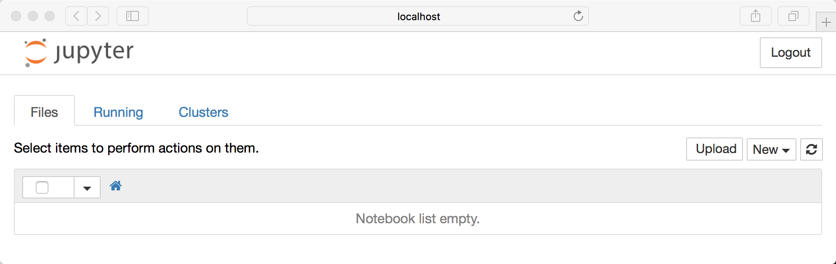
Note that right now you are not actually running a Notebook, but instead you are just running the Notebook server. Let’s actually create a Notebook now!

Creating a Notebook
Now that you know how to start a Notebook server, you should probably learn how to create an actually Notebook document.
All you need to do is click on the New button (upper right), and it will open up a list of choices. On my machine, I happen to have Python 2 and Python 3 installed, so I can create a Notebook that uses either of these. For simplicity’s sake, let’s choose Python 3.
Your web page should now look like this:
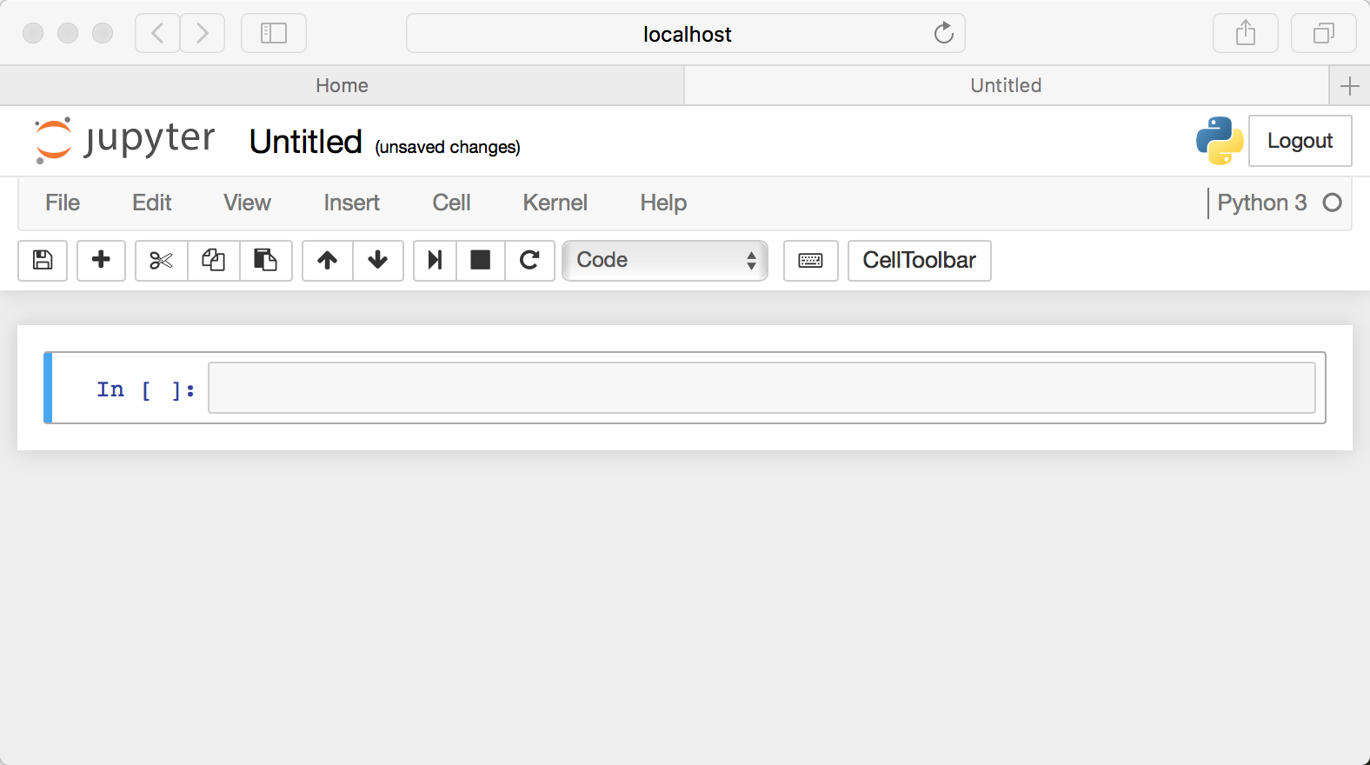

Naming
You will notice that at the top of the page is the word Untitled. This is the title for the page and the name of your Notebook. Since that isn’t a very descriptive name, let’s change it!
Just move your mouse over the word Untitled and click on the text. You should now see an in-browser dialog titled Rename Notebook. Let’s rename this one to Hello Jupyter:
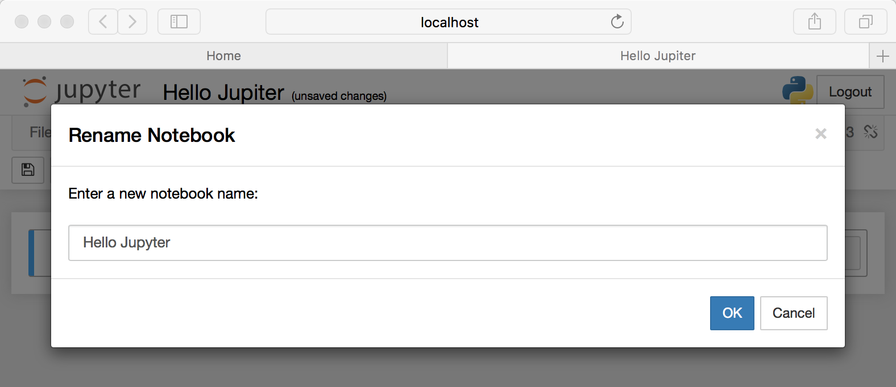

Running Cells
A Notebook’s cell defaults to using code whenever you first create one, and that cell uses the kernel that you chose when you started your Notebook.
In this case, you started yours with Python 3 as your kernel, so that means you can write Python code in your code cells. Since your initial Notebook has only one empty cell in it, the Notebook can’t really do anything.
Thus, to verify that everything is working as it should, you can add some Python code to the cell and try running its contents.
Let’s try adding the following code to that cell:
print('Hello Jupyter!')
Running a cell means that you will execute the cell’s contents. To execute a cell, you can just select the cell and click the Run button that is in the row of buttons along the top. It’s towards the middle. If you prefer using your keyboard, you can just press Shift+Enter.
When I ran the code above, the output looked like this:
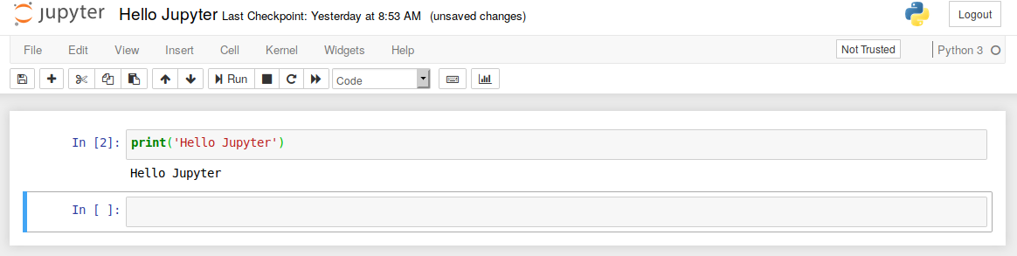
If you have multiple cells in your Notebook, and you run the cells in order, you can share your variables and imports across cells. This makes it easy to separate out your code into logical chunks without needing to rampart libraries or recreate variables or functions in every cell.
When you run a cell, you will notice that there are some square braces next to the word In to the left of the cell. The square braces will auto fill with a number that indicates the order that you ran the cells. For example, if you open a fresh Notebook and run the first cell at the top of the Notebook, the square braces will fill with the number 1.

The Menus
The Jupyter Notebook has several menus that you can use to interact with your Notebook. The menu runs along the top of the Notebook just like menus do in other applications. Here is a list of the current menus:
- File
- Edit
- View
- Insert
- Cell
- Kernel
- Widgets
- Help
Let’s go over the menus one by one. This article won’t go into detail for every single option in every menu, but it will focus on the items that are unique to the Notebook application.
The first menu is the File menu. In it, you can create a new Notebook or open a preexisting one. This is also where you would go to rename a Notebook. I think the most interesting menu item is the Save and Checkpoint option. This allows you to create checkpoints that you can roll back to if you need to.
Next is the Edit menu. Here you can cut, copy, and paste cells. This is also where you would go if you wanted to delete, split, or merge a cell. You can reorder cells here too.
Note that some of the items in this menu are grayed out. The reason for this is that they do not apply to the currently selected cell. For example, a code cell cannot have an image inserted into it, but a Markdown cell can. If you see a grayed out menu item, try changing the cell’s type and see if the item becomes available to use.
The View menu is useful for toggling the visibility of the header and toolbar. You can also toggle Line Numbers within cells on or off. This is also where you would go if you want to mess about with the cell’s toolbar.
The Insert menu is just for inserting cells above or below the currently selected cell.
The Cell menu allows you to run one cell, a group of cells, or all the cells. You can also go here to change a cell’s type, although I personally find the toolbar to be more intuitive for that.
The other handy feature in this menu is the ability to clear a cell’s output. If you are planning to share your Notebook with others, you will probably want to clear the output first so that the next person can run the cells themselves.
The Kernel cell is for working with the kernel that is running in the background. Here you can restart the kernel, reconnect to it, shut it down, or even change which kernel your Notebook is using.
You probably won’t be working with the Kernel all that often, but there are times when you are debugging a Notebook that you will find you need to restart the Kernel. When that happens, this is where you would go.
The Widgets menu is for saving and clearing widget state. Widgets are basically JavaScript widgets that you can add to your cells to make dynamic content using Python (or another Kernel).
Finally you have the Help menu, which is where you go to learn about the Notebook’s keyboard shortcuts, a user interface tour, and lots of reference material.
Starting Terminals and Other Things
Jupyter Notebook also allows you to start more than just Notebooks. You can also create a text file, a folder, or a Terminal in your browser. Go back to the home page that opened when you first started the Jupyter server at http://localhost:8888/tree. Go to the New button and choose one of the other options.
The Terminal is probably the most interesting of the bunch, as it is running your operating systems terminal in the browser. This allows you to run bash, Powershell, and so on in your browser and run any shell command that you might need to there.

Viewing What’s Running
Also on the home page of your Jupyter server (http://localhost:8888/tree) are two other tabs: Running and Clusters.
The Running tab will tell you which Notebooks and Terminals you are currently running. This is useful for when you want to shut down your server but you need to make sure that you have saved all your data. Fortunately, Notebooks auto-save pretty frequently, so you rarely lose data. But it’s good to be able to see what’s running when you need to.
The other nice thing about this tab is that you can go through your running applications and shut them down there.

Adding Rich Content
Jupyter Notebook supports adding rich content to its cells. In this section, you will get an overview of just some of the things you can do with your cells using Markup and Code.

Cell Types
There are technically four cell types: Code, Markdown, Raw NBConvert, and Heading.
The Heading cell type is no longer supported and will display a dialog that says as much. Instead, you are supposed to use Markdown for your Headings.
The Raw NBConvert cell type is only intended for special use cases when using the nbconvert command line tool. Basically it allows you to control the formatting in a very specific way when converting from a Notebook to another format.
The primary cell types that you will use are the Code and Markdown cell types. You have already learned how code cells work, so let’s learn how to style your text with Markdown.

Styling Your Text
Jupyter Notebook supports Markdown, which is a markup language that is a superset of HTML. This tutorial will cover some of the basics of what you can do with Markdown.
Set a new cell to Markdown and then add the following text to the cell:
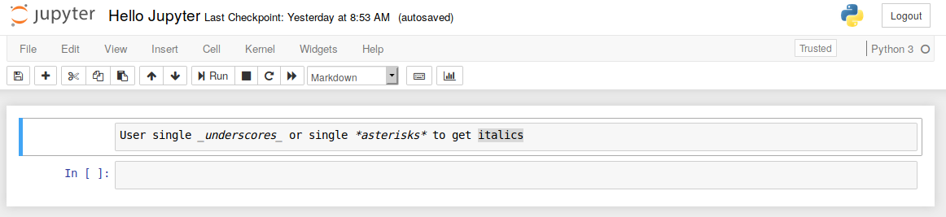
When you run the cell, the output should look like this:
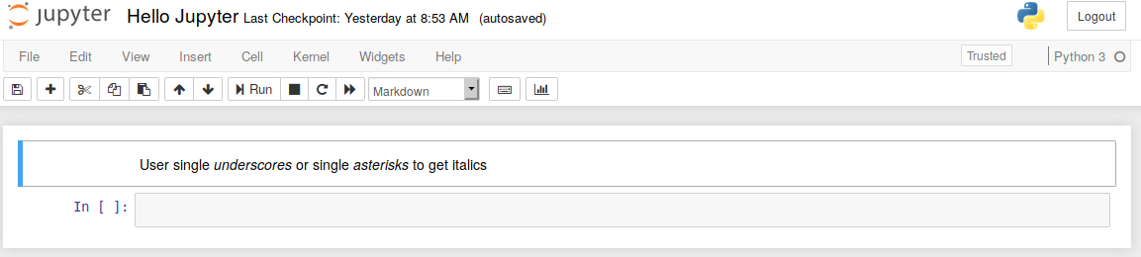
If you would prefer to bold your text, use a double underscore or double asterisk.
Remove ads

Headers
Creating headers in Markdown is also quite simple. You just have to use the humble pound sign. The more pound signs you use, the smaller the header. Jupyter Notebook even kind of previews it for you:
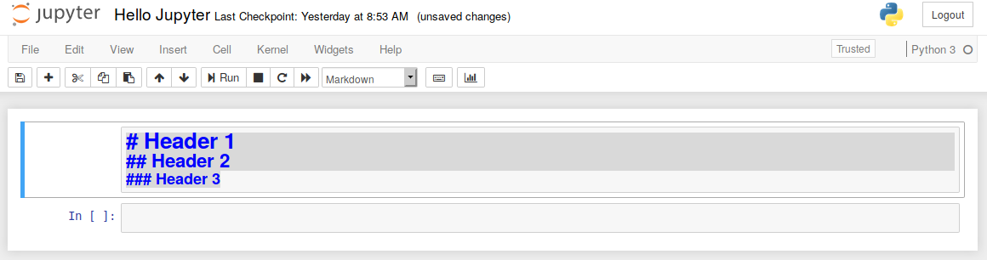
Then when you run the cell, you will end up with a nicely formatted header:
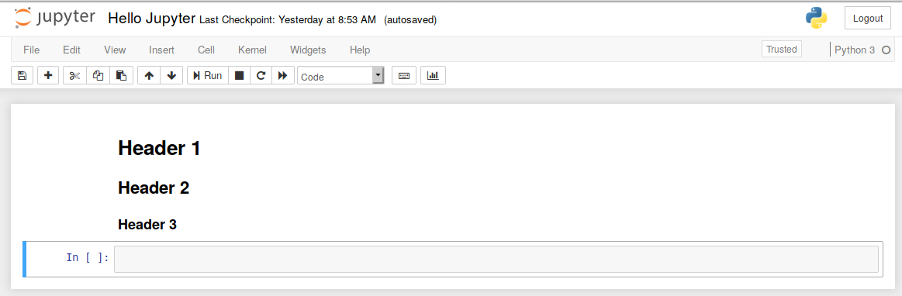

Creating Lists
You can create a list (bullet points) by using dashes, plus signs, or asterisks. Here is an example:
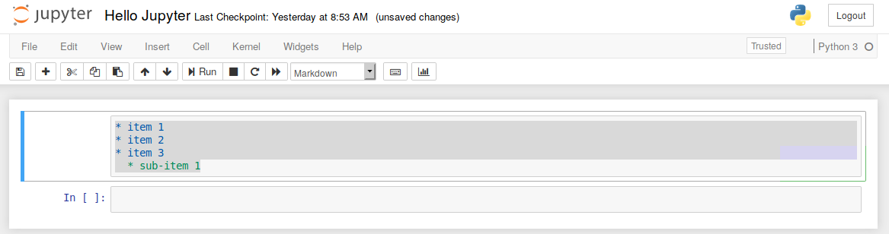

Code and Syntax Highlighting
If you want to insert a code example that you don’t want your end user to actually run, you can use Markdown to insert it. For inline code highlighting, just surround the code with backticks. If you want to insert a block of code, you can use triple backticks and also specify the programming language:
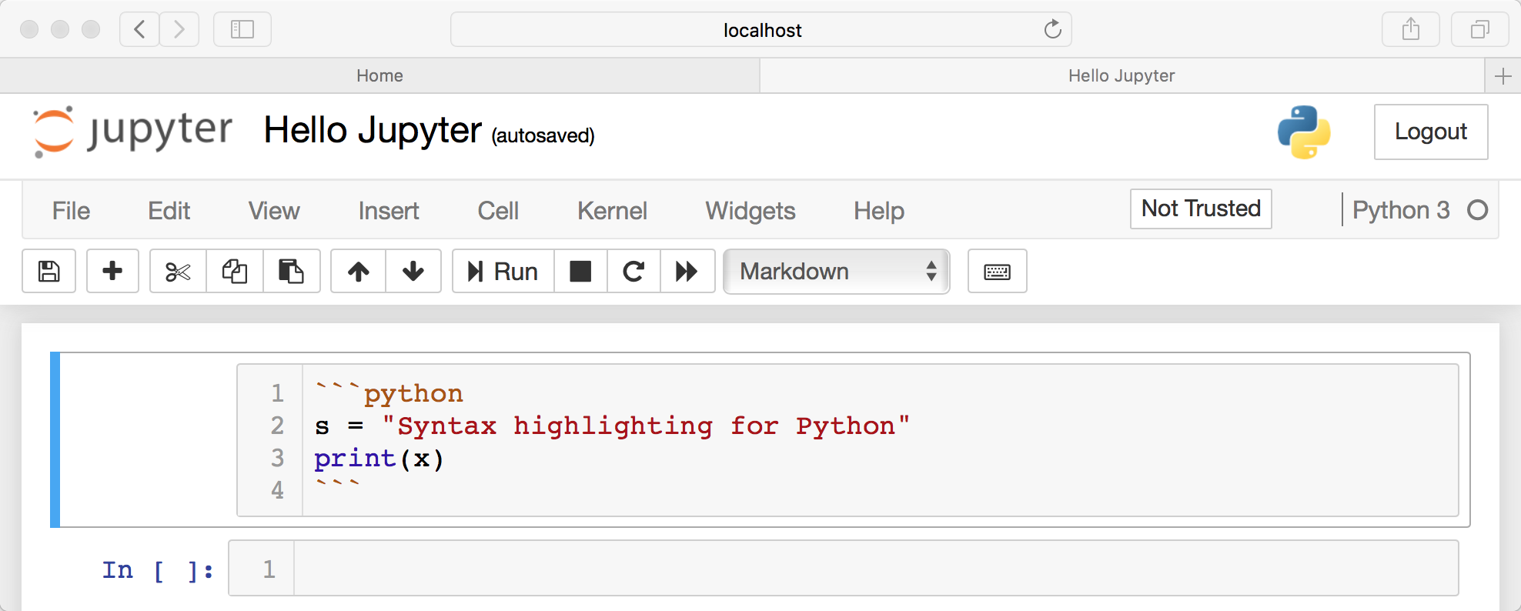

Exporting Notebooks
When you are working with Jupyter Notebooks, you will find that you need to share your results with non-technical people. When that happens, you can use the nbconvert tool which comes with Jupyter Notebook to convert or export your Notebook into one of the following formats:
- HTML
- LaTeX
- PDF
- RevealJS
- Markdown
- ReStructured Text
- Executable script
The nbconvert tool uses Jinja templates under the covers to convert your Notebook files (.ipynb) into these other formats.
Jinja is a template engine that was made for Python. Also note that nbconvert also depends on Pandas and TeX to be able to export to all the formats above. If you don’t have one or more of these, some of the export types may not work. For more information, you should check out the documentation.

How to Use nbconvert
The nbconvert command does not take very many parameters, which makes learning how to use it easier. Open up a terminal and navigate to the folder that contains the Notebook you wish to convert. The basic conversion command looks like this:
$ jupyter nbconvert <input
Notebook> --to <output format>

Example Usage
Let’s pretend that you have a Notebook named py_examples.ipynb and you want to convert it to PDF. Here is the command you would use to do that:
$ jupyter nbconvert py_examples.ipynb --to pdf
When you run this command, you should see some output that tells you about the conversion process. nbconvert will display warnings and errors if there are any. Assuming everything goes according to plan, you will now have a py_examples.pdf file in your folder.
The conversion process for the other file types is quite similar. You just have to tell nbconvert what type to convert to (PDF, Markdown, HTML, and so on).
Remove ads

Use the Menu
You can also export your currently running Notebook by going to the File menu and choosing the Download as option.
This option allows you to download in all the formats that nbconvert supports. The benefit of using the menu is that you don’t need to learn the nbconvert at all if you don’t want to. However I recommend doing so as you can use nbconvert to export multiple Notebooks at once, which is something that the menu does not support.

Notebook Extensions
While Jupyter Notebooks have lots of functionality built in, you can add new functionality through extensions. Jupyter actually supports four types of extensions:
- Kernel
- IPython kernel
- Notebook
- Notebook server
This tutorial will focus on Notebook extensions.

What Are Extensions?
A Notebook extension (nbextension) is a JavaScript module that you load in most of the views in the Notebook’s frontend. If you are handy with JavaScript, you can even write your own extension. An extension can access the page’s DOM and the Jupyter JavaScript API.

Where Do I Get Extensions?
You can use Google or search for Jupyter Notebook extensions. There are actually quite a few out there. One of the most popular extension sets is called jupyter_contrib_nbextensions, which you can get from GitHub. This is actually a collection of extensions that is provided by the Jupyter community and installed with pip.

How Do I Install Them?
Most Jupyter Notebook extensions can be installed using Python’s pip tool. If you find an extension that can’t be installed with pip, then you will likely have to use the following command:
$ Jupyter nbextension install EXTENSION_NAME
This only installs the extension but does not make it active. You will need to enable an extension after installing it by running the following:
$ Jupyter nbextension enable EXTENSION_NAME
You may need to restart your Jupyter Notebook kernel to see the extension.
There is a nice meta extension called Jupyter NbExtensions Configuration that is worth getting for managing other extensions. It allows you to enable and disable your extensions from within the Jupyter Notebook’s user interface and also shows all the currently installed extensions.

